Case Study 07: Supermarket Retail Billing with Discounts and Taxes

1. Problem Statement

Develop a Python program to compute an itemized point-of-sale customer receipt for a 3-item shopping cart. The program reads the unit price and purchase quantity for three items, validates that prices and quantities are non-negative, halts immediately upon detecting invalid input, computes the gross subtotal, applies an automated 10% promotional discount if the subtotal reaches or exceeds Rs. 1000, levies a 5% Goods and Services Tax (GST) on the discounted taxable amount, and prints an itemized billing summary.

2. Objectives

- To read and validate numerical user inputs across multiple items using a controlled iteration loop.

- To implement a for...else loop control structure coupled with an early break statement to catch input errors cleanly.

- To implement conditional discount logic using ternary conditional expressions.

- To compute tax liabilities on net taxable amounts and output formatted financial metrics rounded to two decimal places.

3. Assumptions

- The billing transaction processes exactly 3 distinct merchandise items.

- Unit price is entered as a floating-point number, and quantity is entered as an integer.

- Any negative price or quantity triggers an immediate error message and terminates the transaction without generating a final bill.

- A 10% discount applies if and only if the cumulative subtotal is greater than or equal to Rs. 1000.

- A flat 5% GST is computed strictly on the post-discount taxable amount (taxable = subtotal - discount).

4. Algorithm

- Step 1: Start the program.

- Step 2: Initialize subtotal = 0.

- Step 3: For each item index i from 1 to 3:

  - Prompt and read price as a float and quantity as an integer.

  - If price < 0 or quantity < 0: display "Invalid item values", break out of the loop, and proceed to Step 9.

  - Add the item total to the accumulator: subtotal += price * quantity.

- Step 4: If the loop finishes all 3 items without breaking (else block of loop):

  - Compute discount = subtotal * 0.10 if subtotal >= 1000, else set discount = 0.

  - Compute net taxable base: taxable = subtotal - discount.

  - Compute sales tax: tax = taxable * 0.05.

  - Compute total bill: total = taxable + tax.

- Step 5: Print the formatted subtotal, discount, GST, and final bill.

- Step 6: Stop the program.

5. Flowchart Logic / Diagram

Plaintext
[Start]
│
▼
[subtotal = 0]
│
▼
<For i = 1 to 3> ────────────────────────────────┐
│ │
▼ │
[Input price, quantity] │
│ │
▼ │
<price < 0 or qty < 0?> │
│ │ │
(Yes)│ │(No) │
▼ ▼ │
[Print "Invalid"] [subtotal += price * quantity] │
│ │ │
(break) └────────────────────────────────┘
│ │
│ (loop finished)
│ ▼
│ <subtotal >= 1000?>
│ │ │
│ (Yes)│ │(No)
│ ▼ ▼
│ [disc = subtotal*0.1] [disc = 0]
│ │ │
│ └─────┬──────┘
│ ▼
│ [taxable = sub - disc]
│ [tax = taxable * 0.05]
│ [total = taxable + tax]
│ │
│ ▼
│ [Display Bill Breakdown]
│ │
└─────────────────────┬───────────────────────┘
▼
[End]

6. Pseudocode

Plaintext
BEGIN
SET subtotal = 0.0

FOR i FROM 1 TO 3 DO
PRINT "Enter price of item " + i + ": "
READ price
PRINT "Enter quantity: "
READ quantity

IF price < 0 OR quantity < 0 THEN
PRINT "Invalid item values"
BREAK
END IF

subtotal = subtotal + (price * quantity)
ELSE
IF subtotal >= 1000 THEN
discount = subtotal * 0.10
ELSE
discount = 0.0
END IF

taxable = subtotal - discount
tax = taxable * 0.05
total = taxable + tax

PRINT "Subtotal: Rs.", ROUND(subtotal, 2)
PRINT "Discount: Rs.", ROUND(discount, 2)
PRINT "GST: Rs.", ROUND(tax, 2)
PRINT "Final bill: Rs.", ROUND(total, 2)
END FOR
END

7. Python Source Code

Python
# Supermarket Retail Billing with Discounts and Taxes

# Initialize billing accumulator
subtotal = 0

# Capture pricing and quantities for 3 items
for i in range(1, 4):
price = float(input("Enter price of item " + str(i) + ": "))
quantity = int(input("Enter quantity: "))

# Validate inputs
if price < 0 or quantity < 0:
print("Invalid item values")
break
subtotal += price * quantity
else:
# Evaluate 10% discount threshold (Rs. 1000)
discount = subtotal * 0.10 if subtotal >= 1000 else 0
taxable = subtotal - discount
tax = taxable * 0.05
total = taxable + tax

# Display receipt summary
print("Subtotal: Rs.", round(subtotal, 2))
print("Discount: Rs.", round(discount, 2))
print("GST: Rs.", round(tax, 2))
print("Final bill: Rs.", round(total, 2))

8. Test Cases

Test Case ID | Input Sequence (Price, Qty) | Expected Output | Actual Output | Status
TC_01 (Discount Applied) | Item 1: 300, 2  Item 2: 200, 1  Item 3: 150, 2 | Subtotal: Rs. 1100.0  Discount: Rs. 110.0  GST: Rs. 49.5  Final bill: Rs. 1039.5 | Subtotal: Rs. 1100.0  Discount: Rs. 110.0  GST: Rs. 49.5  Final bill: Rs. 1039.5 | Pass
TC_02 (No Discount Applied) | Item 1: 100, 2  Item 2: 50, 4  Item 3: 100, 1 | Subtotal: Rs. 500.0  Discount: Rs. 0  GST: Rs. 25.0  Final bill: Rs. 525.0 | Subtotal: Rs. 500.0  Discount: Rs. 0  GST: Rs. 25.0  Final bill: Rs. 525.0 | Pass
TC_03 (Negative Price) | Item 1: 250, 2  Item 2: -50, 1 | Invalid item values | Invalid item values | Pass
TC_04 (Negative Quantity) | Item 1: 150, -2 | Invalid item values | Invalid item values | Pass
TC_05 (Exact Discount Boundary) | Item 1: 500, 1  Item 2: 250, 2  Item 3: 0, 1 | Subtotal: Rs. 1000.0  Discount: Rs. 100.0  GST: Rs. 45.0  Final bill: Rs. 945.0 | Subtotal: Rs. 1000.0  Discount: Rs. 100.0  GST: Rs. 45.0  Final bill: Rs. 945.0 | Pass

9. Output Screenshots

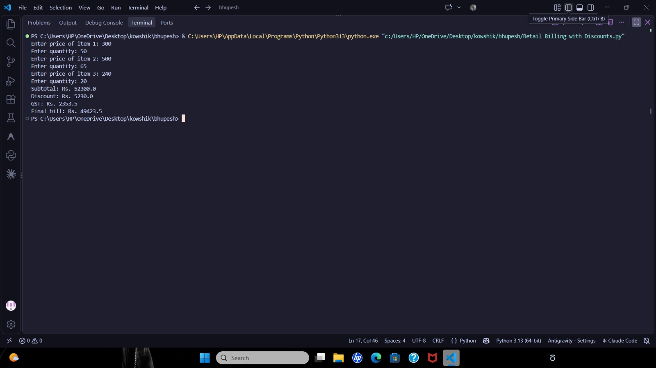

10. Conclusion

The Supermarket Retail Billing program was executed and verified successfully. The script demonstrates the application of Python's unique for...else loop construct, loop interruption with break, inline conditional validation, and chained financial arithmetic for discounts and taxation.

